In the Night at the Museum, Me and several other students from Computer Science, Computer Animation, Photography and Art classes entertained each other with a varied display of projects that they worked on over the last few weeks. This event was very fun as we got to meet friends after school, show other students what we made and learnt about different topics from each other and correct our mistakes, if any.

There were several different projects, however one that caught my eye was a website designed to help any person with the goal of staying fit. The program was *Dolphin Fitness* and it allowed the user to figure out how much food to eat, how much exercise to do and figure out where the user is in terms of fitness.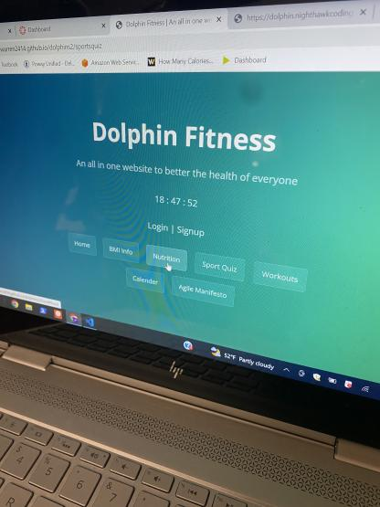

An Image of Dolphin Fitness app/website

This website caught my eye because of the style of the page. The page is extremely bright and catches one’s eye instantly. Also, the uses of the device are immeasurable and the idea of a fitness app would be very viable if sold to the public.

A piece of art that caught my eye was a piece of pottery that looked very cool. It was a pot of tea and it looked like it was made by a professional.

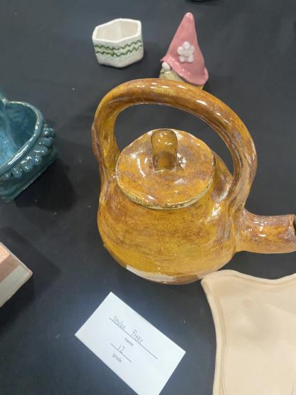

This piece of art was very well made and could easily be passed off as an ancient piece of pottery. In all, this event was very entertaining and fun.